**ITSE 1330 – Intro to C#**

**Code Test 1 – Module 1 - 3**

**There are 2 projects for this Test. Place both project folders in a folder called FirstnameLastnameCSTest1. When you are done with both projects, zip the folder and submit via Moodle. DO NOT ZIP EACH INDIVIDUAL PROJECT, only the outer folder.**

***Make sure you name your controls and form properly. DO NOT leave the default title on the form. The title for each is included in the specifications.***

*Create a Windows Forms application named* ***FirstNameLastNameTest1A***

*Save the application in the FirstnameLastnameCSModTest1 folder.*

Title:  **Translator**

Look at the following list of Spanish words and their English equivalents.

*Spanish                  English*

azul                       blue

rojo                     red

verde                   green

amarillo yellow

morado purple

Create an application that translates the Spanish words to English.  The form should have five buttons, one for each Spanish word.  When the user clicks a button, the application should display the English translation in a Label control.  You should also change the background color of the form to match the color of the word. Should also have an Exit button that exits the application.

Example Form:

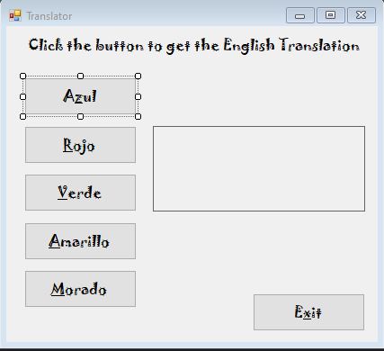

*Create a Windows Forms application named* ***FirstNameLastNameTest1B***

*Save the application in the FirstnameLastnameCSModTest1 folder.*

Title:  **Names and** **Calculator**

Create an application that contains a group box with 2 identifying labels: First Name and Last Name. Add 2 textboxes for the user to enter their First Name and Last Name. Have a Name button that when clicked will concatenate the two names together with a space in between and display the full name in a MessageBox.

Add 2 identifying labels for 1st Number and 2nd Number as well as 2 textboxes for the user to enter 1st Number and 2nd Number. Have a label for the result as well. Make sure autoSize is set to false and it has a border. This label should hold the result and you should also have an identifying label for result. There should be 3 radio buttons for +, - and * in a group box. (RADIO BUTTONS WORK JUST LIKE CHECK BOXES…BUT YOU CAN ONLY CHOOSE ONE IN EACH GROUP) Prefix for a radio button is rad.

When the user enters 2 numbers and chooses one of the operators and clicks the Calculate button it should display the answer to the problem in the result label. You should use an if/else or a switch to change the type of calculation.

Include a working Exit Button.

Example Form:

